National University of Computer and Emerging Sciences



Lab Manual

for

Programming Fundamentals

|  |  |
| --- | --- |
| Course Instructor | Mr. Owais Idrees |
| Lab Instructor(s) | Muntaha Zaigham  Abiha Aftab |
| Section | PF J |
| Semester | Fall 2021 |

Department of Computer Science

FAST-NU, Lahore, Pakistan

# Lab Manual 04

# Introduction

## Objectives

In this lab we will get mainly understanding of

1. Basic Input/Output, Escape Sequences.
2. If, if-else, if-else-if, Nested if
3. Operators and Compound Condition(prefix, postfix)
4. Type Casting

## Task 1

. a. What is the output of

#include<iostream.h>

int main() {

 cout << "Hello/nProgrammers";

 return 0;

}

#include<iostream.h>

int main() {

cout << "Hello\bProgrammers";;

 return 0;

}

1. How to print  "?\  on console , using cout function?

## Task 2:

Design a C++ program that simulates a simple calculator using if-else structure. Program will take two integer numbers as input and an operation as a character '+', '-', '*', '%', '/'. It will then perform that operation on both numbers and print the result.

1.  For division avoid division by zero and should output the result in floating point, for example if n1= 5 and n2= 2 then it should print 2.5. (use typecasting for conversion)

2.  If user enters 'P' print Power of two numbers. (use cmath pow function)

3.  If user enters 'S' print square root of both numbers (use cmath sqrt function)

## Task 3:

Write a C++ code to find the grade from marks. The user is required to input marks obtained and then the program gives him a grade according to his marks. The grading scale is shown below:

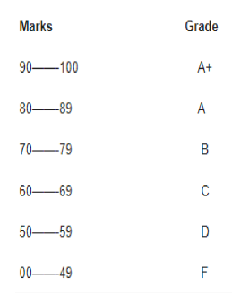

## Task 4:

Write a program that enters a character and determines whether it is a capital  
letter, small letter, digit or special symbol.

## Task 5:

Write a program that that divide two numbers and shows the result with and without Typecasting.

## Task 6:

Write the output of the following program. 